Machine Learning

Laboratory
Experiment No. 1

Python Fundamentals and NumPy Arrays

1. Aim
To study the fundamentals of Python programming and perform numerical computations using NumPy arrays.

2. Objectives
• Understand Python variables and dynamic typing.
• Use control structures such as loops and conditional statements.
• Work with Python data structures like lists and tuples.
• Define and use Python functions.
• Create and manipulate NumPy arrays of different dimensions.
• Perform indexing, slicing, reshaping and random number operations using NumPy.

3. Software Required
• Python 3.x
• Jupyter Notebook / Google Colab / Anaconda
• NumPy Library

4. Python Fundamentals

Python is a high-level interpreted programming language widely used in data science, machine learning and artificial intelligence.

Python supports dynamic typing, which means the data type of a variable is determined during program execution.
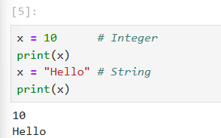
Python also supports various control structures:
• Conditional statements – if, elif, else
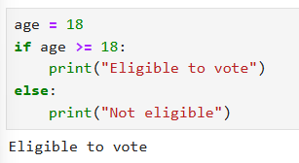

• Loops – for loop and while loop
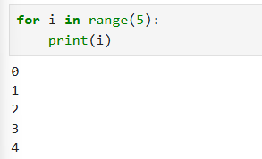
• Functions – reusable blocks of code
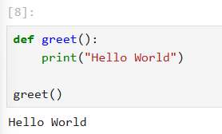

5. Python Fundamentals
Python is a high-level programming language widely used in data science, machine
learning, and artificial intelligence.
Python follows dynamic typing, meaning the type of a variable is determined
automatically during execution.
Python supports several data types
• Integer
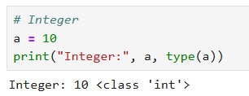
• Float
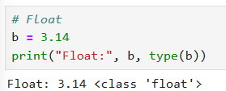

• String
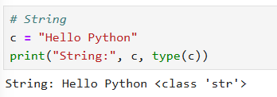
• Boolean
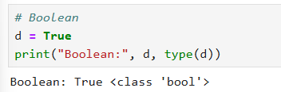
• List
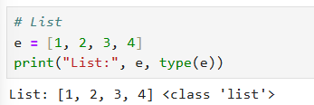
• Tuple
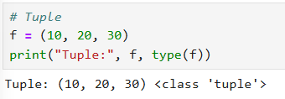
• Dictionary
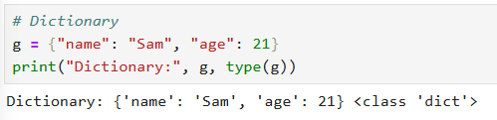

NumPy

NumPy (Numerical Python) is a powerful Python library used for numerical computation.

The main data structure in NumPy is ndarray (N-dimensional array).
It allows efficient storage and manipulation of large numerical datasets.

Creating a numpy array:
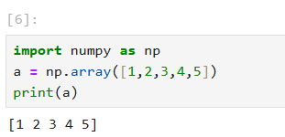

Important attributes of NumPy arrays:
• ndim – number of dimensions
• shape – structure of array
• size – total number of elements
• dtype – data type of array elements
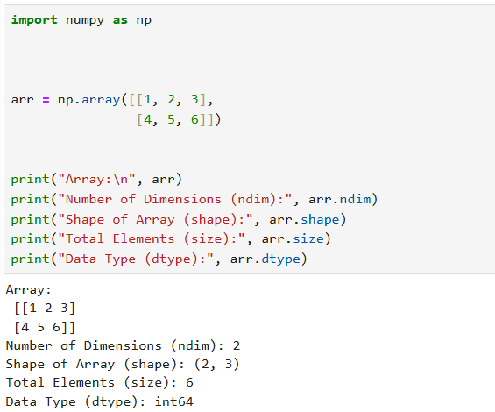

6. Types of NumPy Arrays

• Scalar (0-Dimensional Array): A scalar represents a single numeric value.
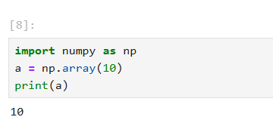
• Attributes:
Ndim:
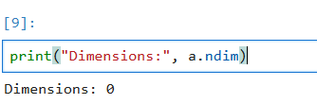

Shape:
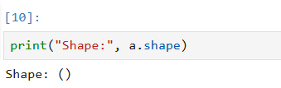
Size:
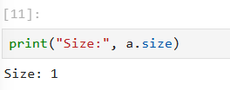
Dtype:
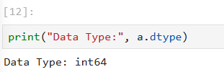

• Vector (1-Dimensional Array): A vector is a one-dimensional array containing
multiple elements.
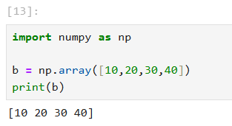
• Attributes:
Ndim:
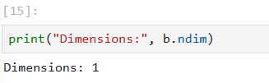
Shape:
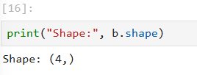
Size:
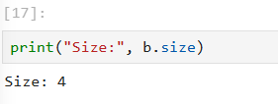
Dtype:
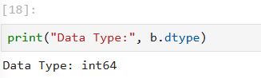

• 2-Dimensional Array (Matrix): A 2D array represents data arranged in rows and
columns.
• Attributes :
Ndim:
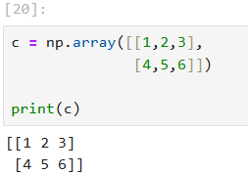
Shape:
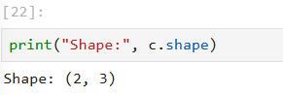

Size:
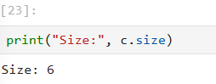
dtype:
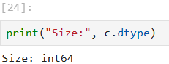

• Tensor (3-Dimensional Array): A tensor is a multi-dimensional array with more
than two dimensions.
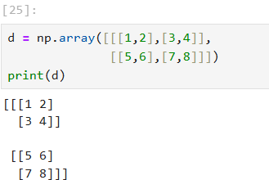
• Attributes:
Ndim:
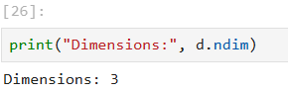
Shape:
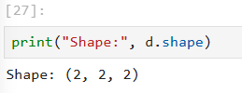

Size:
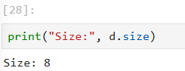
Dtype:
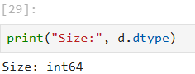

7. Creating Arrays Using NumPy Functions

• np.ones(): Creates an array filled entirely with ones.
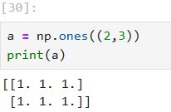
• np.zeros(): Creates an array filled with zeros.
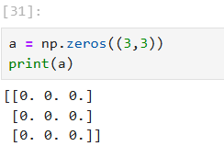
• np.random.rand(): Generates random floating-point numbers between 0 and 1.
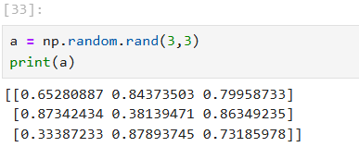

• np.random.randint(): Generates random integers within a given range.
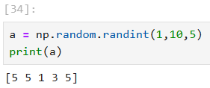

• np.random.seed() – Pseudo Random Numbers. Computers generate pseudo-random numbers using algorithms.
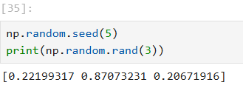
Using np.random.seed() ensures the same random numbers are generated every time the program runs, which is useful for reproducibility in machine learning.

10. Result

The experiment successfully demonstrated Python fundamentals and NumPy array
operations including scalar, vector, matrix and tensor creation.

11. Conclusion
NumPy arrays provide efficient numerical computation and are widely used in machine
learning and data science applications.

12. Viva Questions

1. What is Python?
Python is a high-level, interpreted programming language used for web development, data science, machine learning, and automation. It is known for its simple and readable syntax.

2. What is NumPy?
NumPy (Numerical Python) is a Python library used for numerical computations. It provides powerful array objects and mathematical functions.

3. What is ndarray?
ndarray stands for N-Dimensional Array. It is the main data structure of NumPy used to store and process large numerical datasets efficiently.

4. What is a scalar array?
A scalar array is a 0-dimensional NumPy array that contains only one single value.
Example
np.array(10)

5. What is a vector in NumPy?
A vector is a 1-dimensional NumPy array containing multiple elements arranged in a single row.
Example
np.array([1,2,3,4])

6. What is a 2D array?
A 2D array is a NumPy array with rows and columns, similar to a matrix.
Example
np.array([[1,2],[3,4]])

7. What is a tensor?
A tensor is a multi-dimensional array with more than two dimensions (3D or higher).
Example
np.array([[[1,2],[3,4]]])

8. What is np.ones()?
np.ones() is a function used to create an array filled with the value 1.
Example
np.ones((2,3))

9. What is np.zeros()?
np.zeros() creates an array filled with zeros.
Example
np.zeros((3,3))

10. What is np.random.rand()?
np.random.rand() generates random floating-point numbers between 0 and 1.
Example
np.random.rand(3)

11. What is np.random.randint()?
np.random.randint() generates random integers within a given range.
Example
np.random.randint(1,10,5)

12. What is np.random.seed()?
np.random.seed() is used to produce the same random numbers every time the program runs, which helps in reproducibility.
Example
np.random.seed(10)

13. Difference between Python list and NumPy array
Python List | NumPy Array
Stores different data types | Stores same data type
Slower for numerical operations | Faster for numerical computation
Less efficient for math operations | Highly efficient for calculations

14. Types of NumPy arrays
- 0D Array (Scalar) – single value
- 1D Array (Vector) – list of elements
- 2D Array (Matrix) – rows and columns
- 3D Array (Tensor) – multi-dimensional data

15. What is indexing in NumPy?
Indexing is the process of accessing specific elements of an array using their position (index).
Example
a[0]
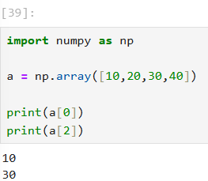

16. What is array slicing?
Slicing is used to extract a portion of an array using a range of indices.
Example
a[1:4]
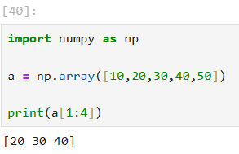

17. What is negative indexing in NumPy?
Negative indexing is used to access elements from the end of the array.
Example
a[-1]
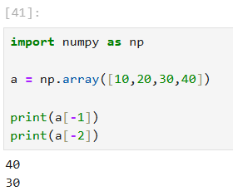

18. What is the use of np.arange()?
np.arange() creates an array with evenly spaced values within a given range.
Example
np.arange(0,10,2)
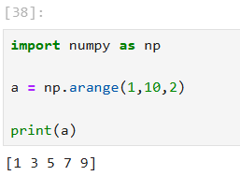

19. Difference between arange() and linspace()
arange() | linspace()
Uses step size | Uses number of elements
End value may not be included | End value is included
Example
np.arange(0,10,2)
np.linspace(0,10,5)
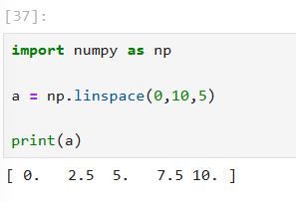
20. Use of np.ones() and np.zeros()
They are used to create arrays initialized with constant values (1 or 0), often used in matrix operations and machine learning initialization.

21. Use of np.random.rand()
It is used to generate random floating-point numbers between 0 and 1, commonly used in simulations and machine learning.

22. Use of reshape() in NumPy
reshape() is used to change the shape of an array without changing its data.
Example
a.reshape(2,3)
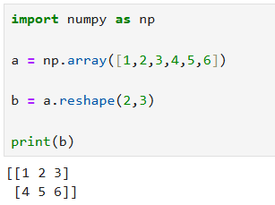

23. Meaning of ndim, shape, size, and dtype
Attribute | Meaning
ndim | Number of dimensions of the array
shape | Structure of rows and columns
size | Total number of elements
dtype | Data type of array elements
Example
a.ndim
a.shape
a.size
a.dtype

